**Taco Invaders**

Your task is to defend the earth from the invading tacos that are taking over the earth. Our hero the monkey possesses photon torpedoes that can destroy the tacos as they enter the earth’s atmosphere. You can move the monkey left or right with the left and right arrow keys. When the space bar is pressed it launches a photon torpedo which when it collides with the taco, destroys it. Unfortunately, the two programmers you hired to write this software were not as great of a programmer as you are and made some errors. Your task is to find and fix those bugs. There is only one bug in the program. This is a process known as debugging. The first step in debugging is to recognize the symptom of what the program is doing incorrectly. Sometimes this can be a bit tricky in that there may be more than one symptom from an underlying cause. They only way to get good at debugging is to practice it a lot.

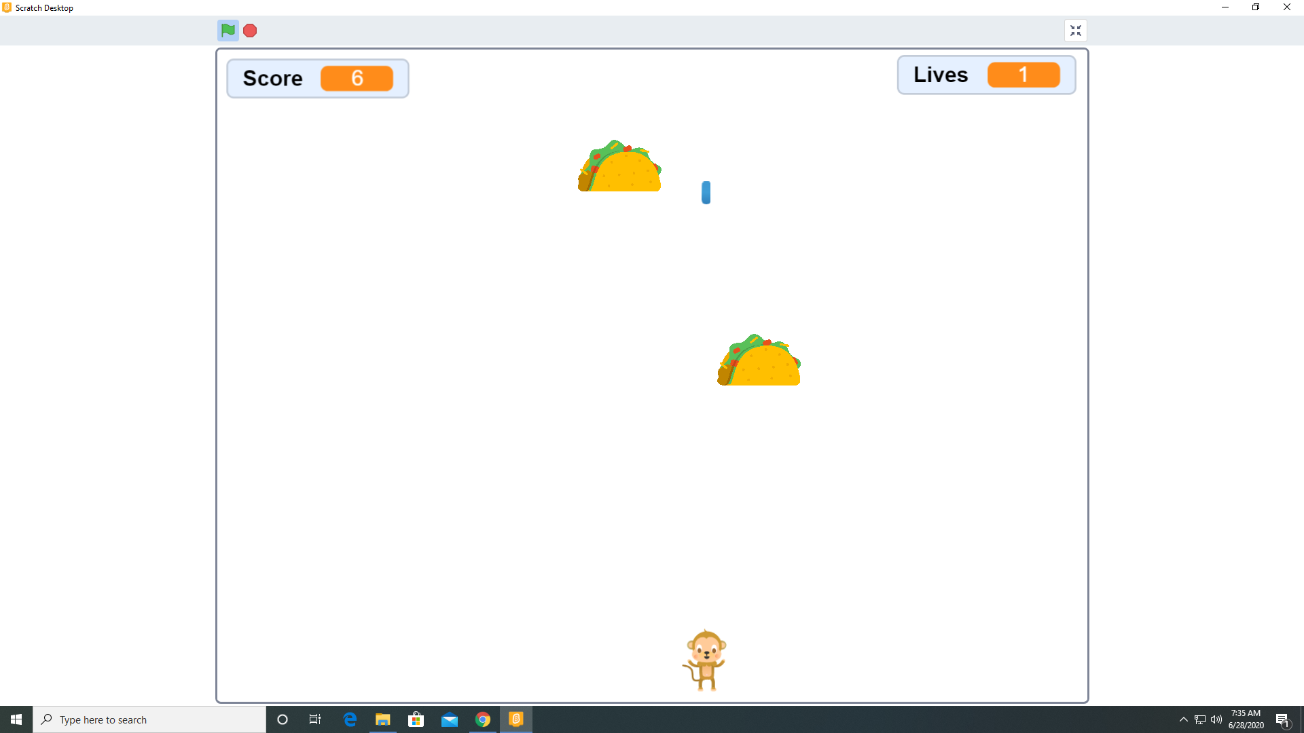

Screen shot of working program as designed